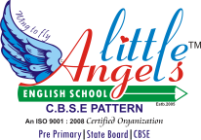
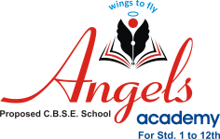
LEELAVIJAY EDUCATION SOCIETY’S
LITTLE ANGELS ENGLISH SCHOOL
Nageshwarwadi,Aurangabad.
SYLLABUS AND ACTIVITY PLANNER FOR THE MONTH OF JUNE,2025 FOR THE ACADEMIC YEAR 2025-26 FOR NURSERY
1. ENGLISH: ORALS
- RHYMES: RHYME BOOK
1. TWINKLE TWINKLE ………………….
2. A, B, C, D ………..
3. BAARISH AAYI ………………….. HINDI RHYME
4. YE RE YE RE PAVSA ………………… MARATHI RHYME
- PHONETICS:
PHONIC SOUNDS ………………….. A, B, C, D
- WRITTEN:
STANDING LINE ………………………………
SLEEPING LINE ………………………………
- ACTION WORDS:
SITTING , STANDING , JUMPING, DRINKING
2. MATHS: ORALS
NUMBERS 1-5

- WRITTEN:
- STANDING LINE ………………………………
- SLEEPING LINE ………………………………
- CIRCLE ……………………………………….
- SHAPE : CIRCLE / ROUND

3. E V S: ORALS
- COLOUR – GREEN …………………
GREEN ,GREEN , GREEN
NATURE IS GREEN
PARROT IS GREEN
THAT LOVES CHILLIES GREEN
GREEN GREEN GREEN
& WATERMELON GREEN
CAPSICUM GREEN AND CORIANDER GREEN
I LOVE ONE COLOUR THAT IS GREEN

GENERAL ETIQUETTES:
1. BRUSH YOUR TEETH TWICE A DAY.
2. TAKE A BATH DAILY.

